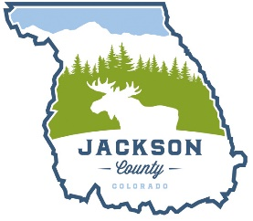
JACKSON COUNTY BOARD OF COUNTY COMMISSIONERS AGENDA
Date: Tuesday April 15, 2025
Time: 8:30am
Location: Conference Room at the Administration Building
8:30am Discussion and Consideration with Armstrong/Lochner regarding airport RFP – Board action as necessary
9:30am Adjourn

Meeting link: https://us06web.zoom.us/j/85639880619

